

Time: 3 flours

Institute of [nformatioii Technology Jahangininpar University

2"d Year 1 Serftester B.Ss. tHons.) Finai Esainin¥ion; 2018

Sub/etc:›tlgod1hnlXno1*ie Scsson:2016.20t7

Cot Tilt:lTUl0t Full Mad‹s! 60

Answer any iv 5 from tiir follou-ing questions, Figures ni the right iitdicote fire ninrks.

a) Expl.aim Etfcicncy of rim algorithm vitli cx:un plc Deduce the rtiniiing time efficiency of 4

Sequeuti. I ze:trclt 2lgoritlzm.

b} Whir is Asymplolic ConJplcxif}' Gi e n 1 nrt description nhout D--notation and B - rotation.

1. AJlnlyze lnsei1ion twit. 
2. Compare II\r urdei4 of' Pro \lh a/ - it(n - 1) ni\ñ nz.

2. n} SI o v ti›,t the l«i ¿c i clcn›ent in «ib tn:e of.a lie.up is iii the met of ihc sub toe. 2

 j{j¿ ]1enp ] yoperty. })]tlstrole the opcmtion of 3+3



the Ncc/5;J' (A.?›) run the army a {27,17.3, 16,13,10,1



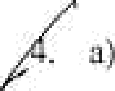

 

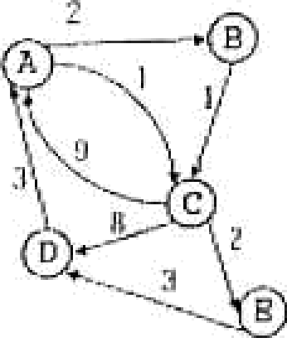

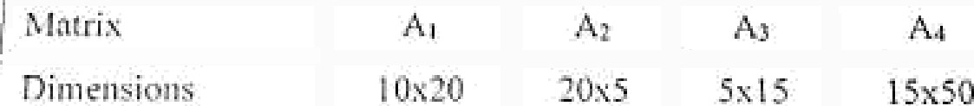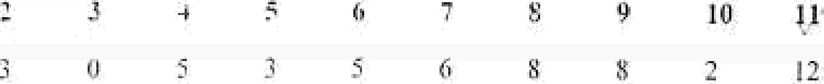

i

I



P.T.O

 Whflt arc the *0-I ioiapsack* mid *fi acti•»«l* Ropsnc£ problem† HOW do yOu exp}Jpq



*dynamic p••zi’oouuing* or ¿;roe‹fj would be applicable for computing the opti"' aJ S olu’

for these two problems and the other algorithm would fail,

*› Cont} C£ o data file with 35000 clinrocters. The characters frequencies given by;

in the file occur wlty $

C d g h j k



frequency (in thousand} d 9 3 4 7 6

Generate the variable length code word usl*8 ffii@ooo *code* n/gpriifiin.

* ) Whnt down the algorithm ofocriri/y *selection problem* 3

1. 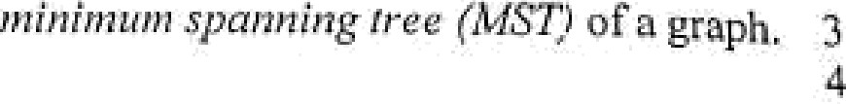a) Write down the *Prin 's algorithm* to calciilate the

) Consider the following graph,

10



6

Compute the

minimum sprinting tree for the nbove mentioned B*• r* •°›fl s *'r ›• ''

spanning free of the following graphs. Does 5



Kruskal’s algorithm work correctly on graphs heat have negative edge weights?

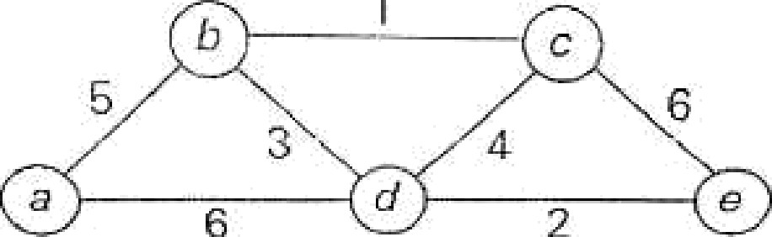

EMD

**lfls lttltC,** p( Infonr ation Tecluiology

B.Sc(Honoi-s) 2"‘ I hangirnaga- University

Yeai’ 1"

## Seitiester Final Examination 2018

Course: IT 2109(Statistics and Ptob«bility Theory)

Full M<ks: so

# Time: 3 hours



[Answer any FIVE oPihe fOl lOWiilg questions. Each set of questions cnrry equnl marks

## .(a)What do you mean by statistics? Write down the important applications of

## statistics in information technology. DRfine data wiih example. 4

## Define vai'Iilble with example. Briefly explain the qualitative and quantitative

## variable. 4

* 1. What is frequency distribution7 Why do yOU use StlGh dlsiribution? Why,

## graphical presentation is so important? 4

## What Is dispersion7 What are the measut’es of dispersion* 4

1. Wi’ite down the merits and demerits of mean deviation and Stdlldard

## deviation.4

## A frequRncy distribution of weights (in kg)of 45 students are given below:

Income irt Taka

## uenc

## 50-St 55-60 60-65 65-70 70-75 75-80

## )0



## Compute the mean deviation and coefhcient of variation. 4

## *. a )* What is coefficient of variation (CA)? Why coefficient of variation is so important? 4



t

## Establish the relation between q’s and v’s. 4

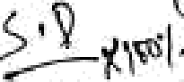

(c) Compute the ktirtosis (bled upon the fourth moment about the mean)of

J\ ‘" the following frequency distt ibution, 4

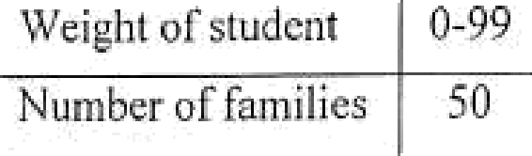s‘

|  |  |  |  |  |  |  |
| --- | --- | --- | --- | --- | --- | --- |
| Weight of student 0-99  Number of families 50 | I 00-T 99 | 200-299 | 300-399 | 400-499 | JD0-599 | b00-d99 |
| 70 | 203 | 406 | 403 | 42 | 5 |

## Write down the uses of colTRlation coefflcient. 3

## The following table shows lhe data of the heights of father and his son : 9

|  |  |  |  |  |  |  |  |  |  |
| --- | --- | --- | --- | --- | --- | --- | --- | --- | --- |
|  | |  |  |  | 168 | 167 | 169 | 170 | 172 |
|  |  | 157 | UR | 145 | 172 | U8 | 172 | 169 | 171 |

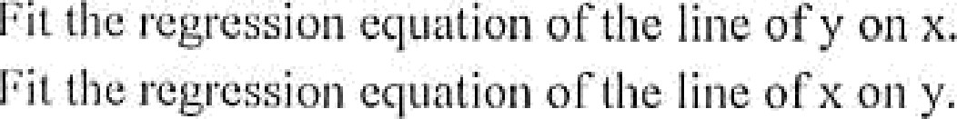

 



the ter ins cxpcl'iiTicnl, snliiplc sjxicc end event wiih crumple. Write

* 1. TwD tllOllSilll£l i iintloinly selected adults wclc asked if they think they ara financially better off than their parents. The following table gives the two- way classification of the responses based on the education levels of the

persons included in the survey and whether they are financially

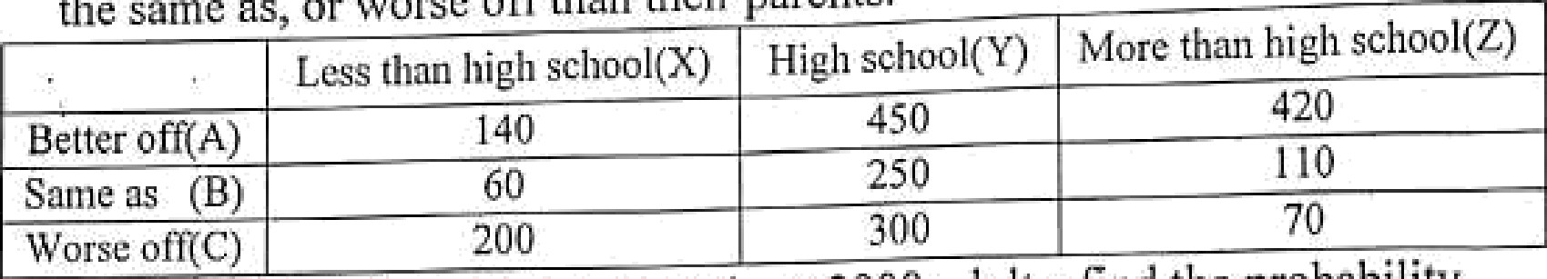

the same as, or worse orra«n their parents.

Detier off(A)

Saint as (B)

140

60

450

250

lvtore than high school(Z)

420

no

70

one adult is selected at ’i andoin from these 2000 adiilu, find the probabllity

Worse otgC)

200

# better on,

lf

that ihis adult is

* + 1. P(Financially better off given less thnn high school)

1. P(High school given flnancially worse off)
2. P(better off rind high school)
3. P(more than high school and worsc off)

write down the conditions of a binomial experiment.2

1. According to a National Public Radio poll, 46% of' A merican School plincipals believe that students pay little attention to science education

pt ovided in schools. Suppose that this reeult is true for the current population of American school principals. 10

* 1. Let *x* be a binomial random variable denoting the number of American

school principals in a random sample of 7 who do not believe that

students pay little attention to science education taught in schools. Write

I

the probability distribution of sand draw n graph of the probability

distribution. Determine the mean and standard deviation cfs.

*ii ) Find* the probRbility that in a random sample of 7 American school principals, at mo.st 4 believe that students pay little attention to science education taught in schools.

7. (a)Define hypothesis. What is null alid alternative hypothesis? Define level

of significance.4

1. What is power of the test and p-value? Define confidence interval with example.
2. Suppose the manager of a textile industry suspects that the mean time lost doc to the sickness of the night shifl workers excecds the mean time for the day shi h workciz. To check it, the manager randomly selected 12 workers i n cach sliifi catcgoiy nn‹1 ircoi‹l the ntiiiibor or dnys lost dtie to sickness

|  |  |  |  |  |  |  |  |  |  |  |  |
| --- | --- | --- | --- | --- | --- | --- | --- | --- | --- | --- | --- |
| Night him | 12 | 10 | 20 | 1. 5 | 18 | 9 | 12 | 10 | 21 | 25 | 13 |
| Day Shifl |  | 1 0 | 15 | 9 | 12 | 16 | 15 | 20 | 5 | 18 | 12 |

If the Humber of’days |7el' year lost chic to the sicluiess for thc night shift

and day slii fl k ’s NIJ ])Q] lually t!ish ibiited with mean pi and pi and variancep and z$ respectively, test the significance of the difference of

populatinn inenns if the population variances are riot equal. The table value is at 5% level nf significance is 1.72.